Task 1: Initial Setup + Local Run
- Fork this repository and clone it locally.
- Run npm install and npm start.
- Confirm that Welcome to Crecita is visible on localhost:3000.
Step-by-Step Guide: How to Run Locally
- Install Node.js and npm
Go to the official Node.js website: https://nodejs.org/en/download
- Download the LTS version (Recommended for most users).
Verify Installation:
- node -v
- npm -v
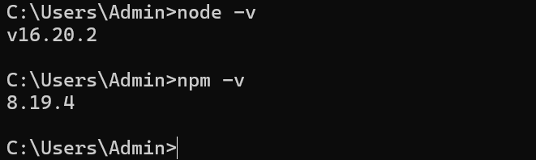
- Clone the Repository (Download the Project)
Open your terminal or command prompt and run:
- git clone https://github.com/RachitK02/aws-devops-handson.git
Replace <your-repo-url> with the actual link to the GitHub repository.
- Go Into the Project Folder
After cloning, move into the folder:
- cd aws-devops-handson
This is the name of the folder that contains your project files.

3. Install Dependencies
This installs all the libraries your app needs to work:
- npm install

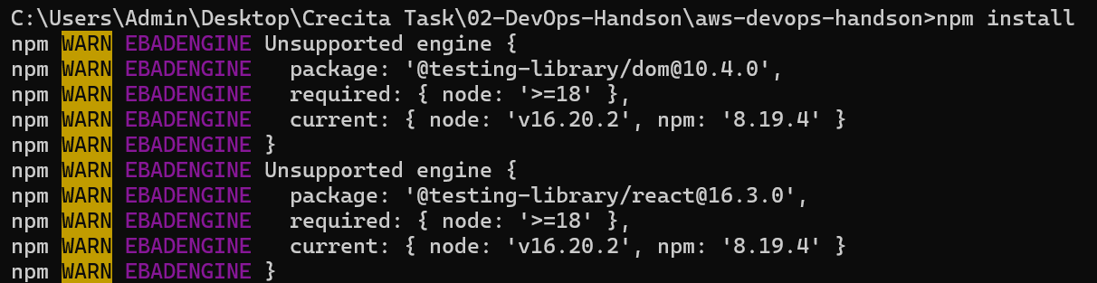
It reads the package.json file and installs the required packages.

4. Start the Application
Run this command to start the app:
- npm start

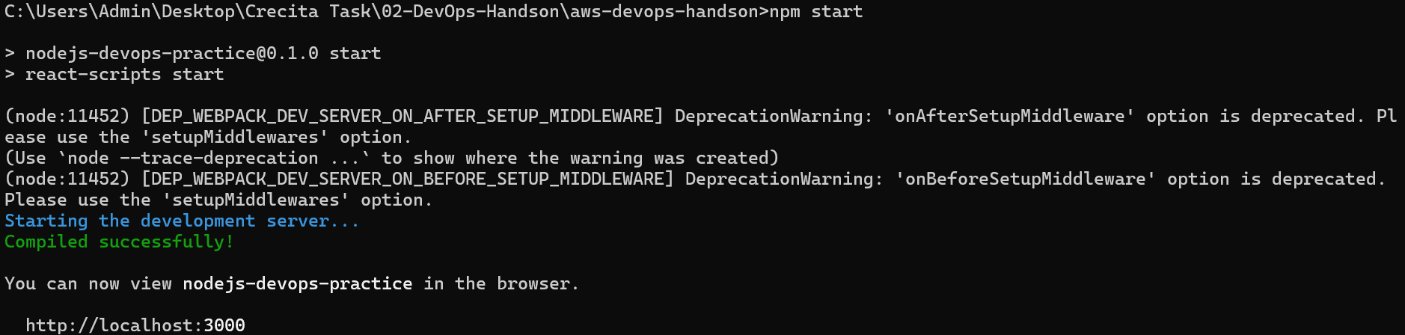
It will compile the app and start a local web server.

5. Open the App in Your Browser
Go to this address in your web browser:
http://localhost:3000

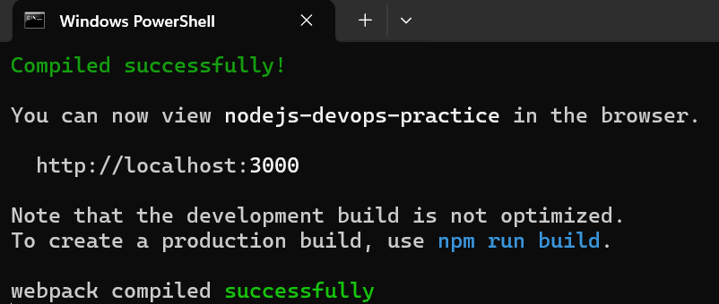
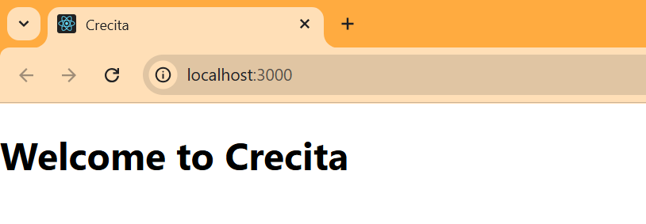
You should see your app running!

